RobotX Model Boat

Controller Documentation

# Introduction

This is an outline of the electronic hardware and software design for the RobotX Model Boat. This is in the rough; it is not very clean but hopefully correct!

# Overview

Below is a system diagram much of which is based upon the system used for the final project in Robitics I, fall 2013.

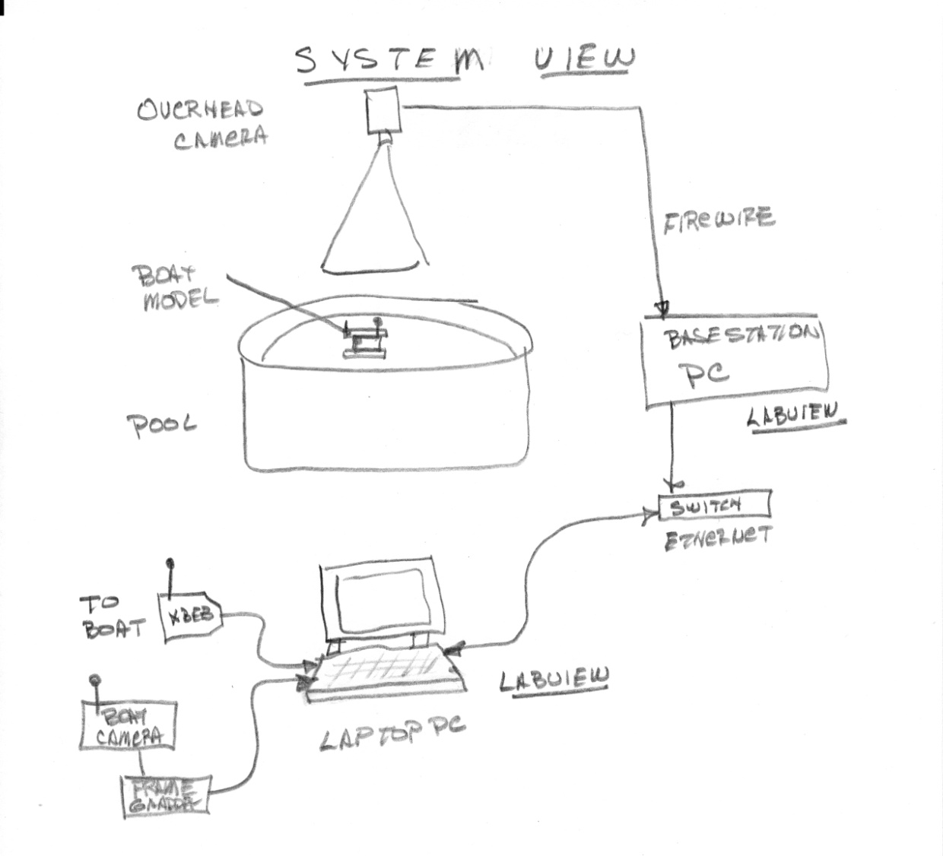

# The Boat Model

Below is a system view of the boat itself

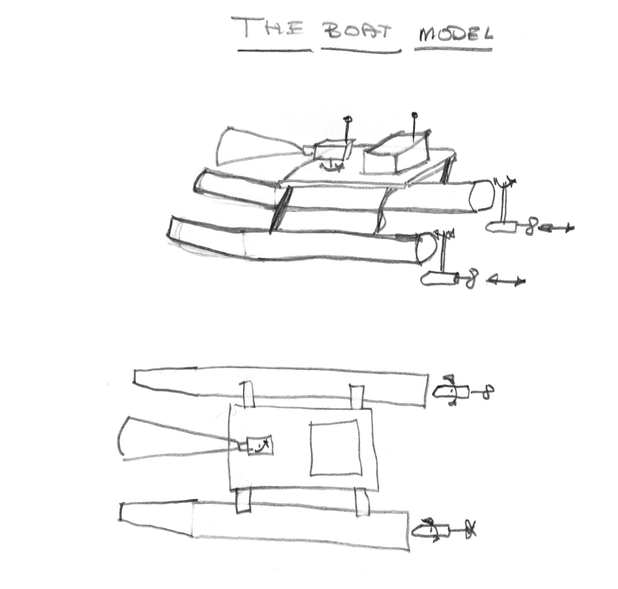

# The Stuff on the Boat

Below is a diagram of all the stuff on the boat.

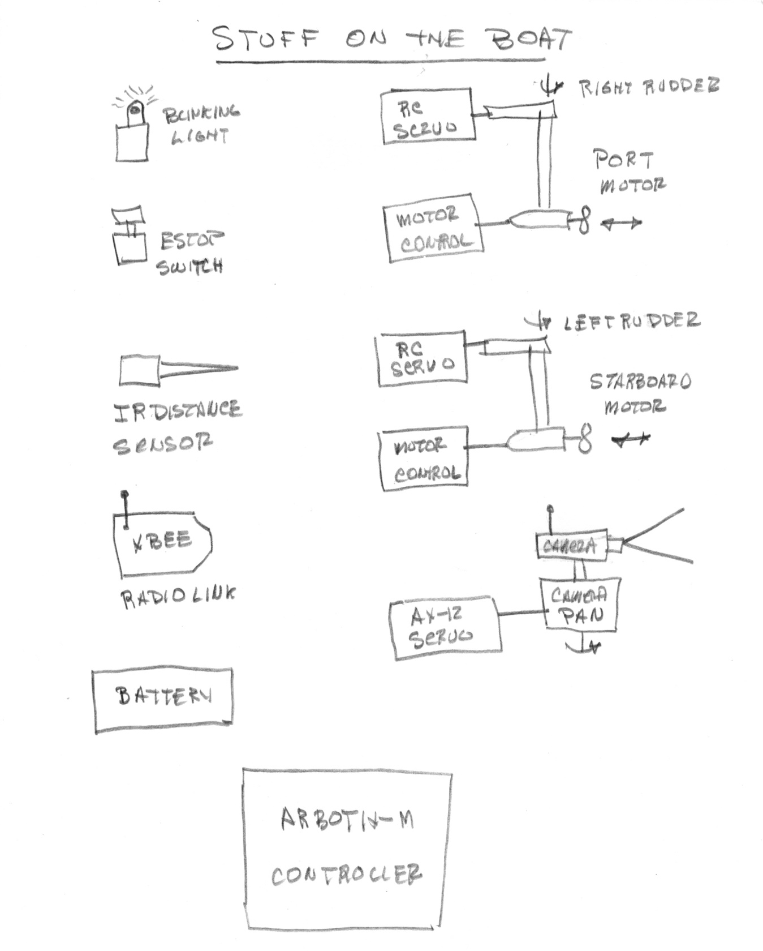

# The Controller

The controller used is the Arbotix-M supplied by Trossen Robotics

<http://www.trossenrobotics.com/p/arbotix-robot-controller.aspx>

The link above is the major gateway to all the information for the product.

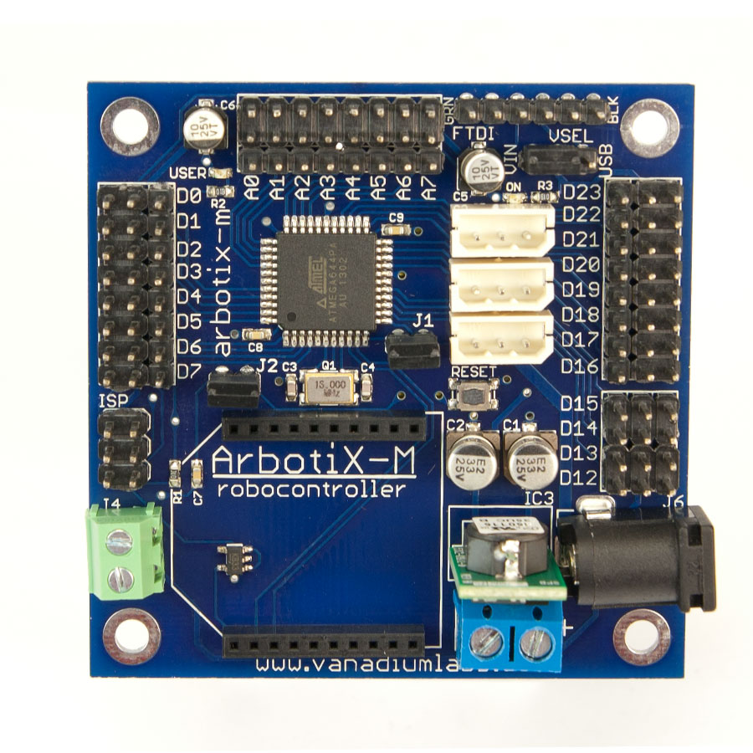

Attached to the controller is an XBEE Series 1 Radio:

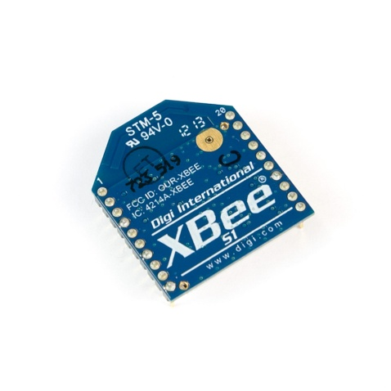

Attached to the laptop PC is the other end of the radio link, another XBEE radio attached to an USB interface card shown below:

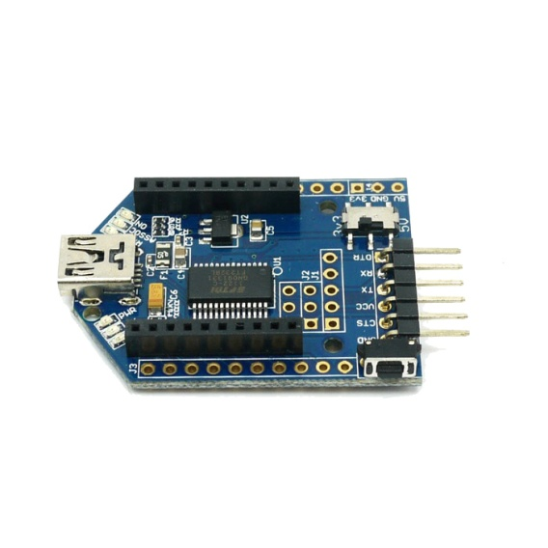

Two Hitec Servos, HS-5645WP are used to steer the motor pods:

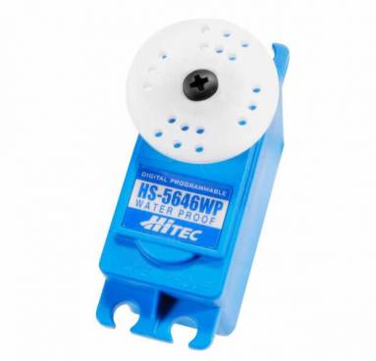

Two motor controllers, Viper 10, are used to control brush motors to move the boat:

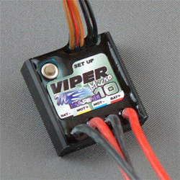

A Sharp IR sensor is used to avoid obstacles:

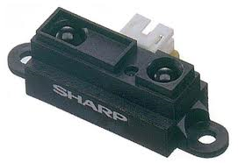

To pan the camera a Dynamixel AX-12 servo is used:

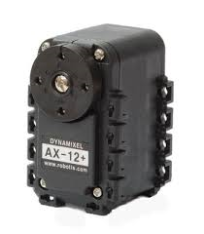

To program the Arbotix-M, a programming card is needed which connects to the ISP (In System Programming) port on the Arbotix-M and the USB port on a PC:

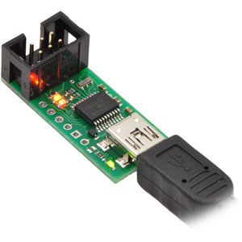

# Wiring Diagram

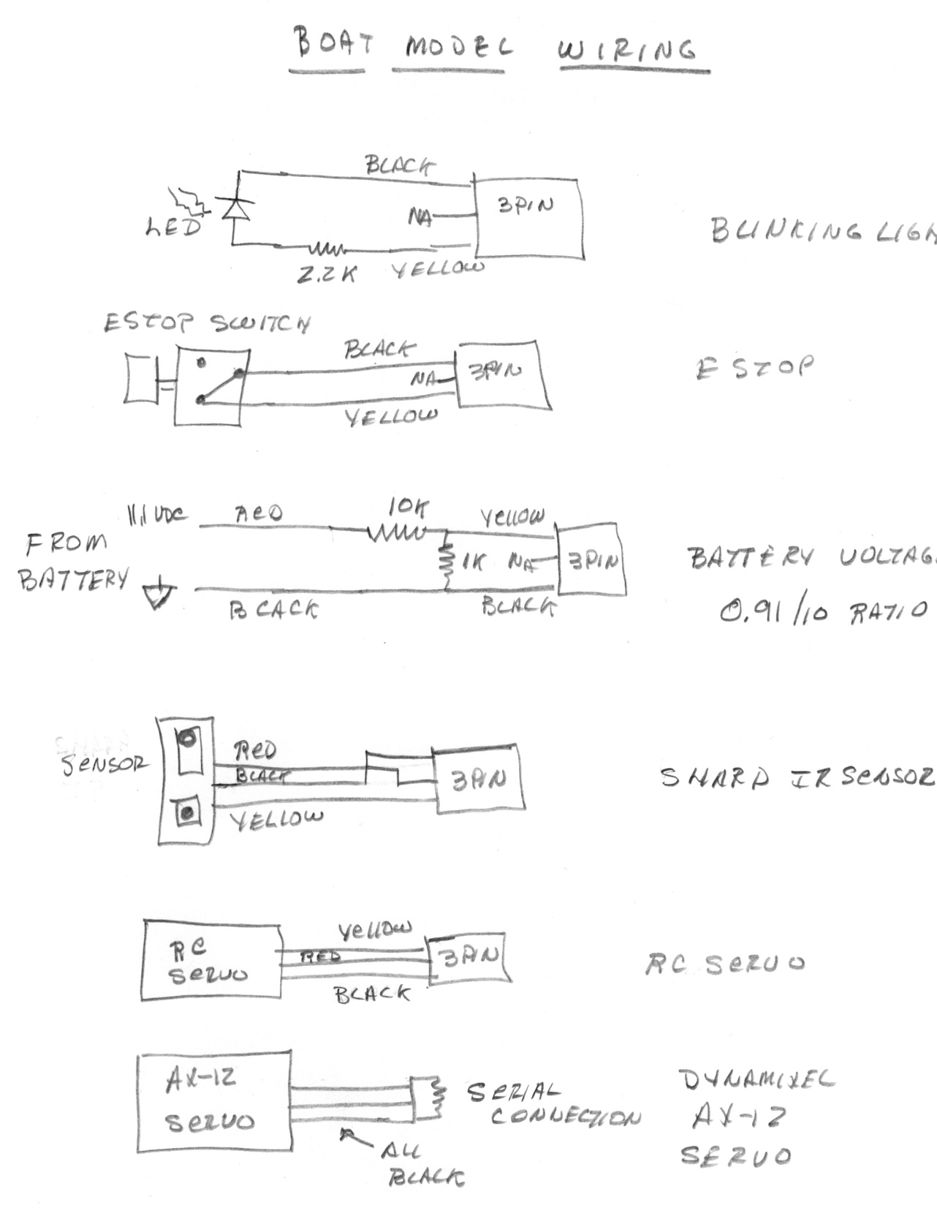

# Wiring Harness

# boat model harness.jpg

# The Controller Software

The software for the controller is based upon the Arduino development software. It is a C/C++ based simplified code scheme. Again the link below is the only gate way to the information:

<http://www.trossenrobotics.com/p/arbotix-robot-controller.aspx>

THIS IS NOT PLUG AND PLAY!!!!!!!!!!!!!

# Software Downloads

The link below provides step by step instructions by which you can create a develop tool set to program the Arbotix-M and the XBEE radios.

<http://learn.trossenrobotics.com/arbotix/7-arbotix-quick-start-guide>

A great number of software packages are necessary for this to all work. The downloads below, in order are:

X-CTU.exe //program for XBEE radio settings

arduino-1.0.5-windows.exe //program for programming the Arbotix-M

CDM 2.08.30 WHQL Certified (1).zip //FTDI drivers used with FTDI to USB cable

dynaManager1.2.zip //program for setting up the AX-12 servos

JavaSetup7u45.com //required by dynaManager written in Java

xbeeProfilesInterbotiX-master.zip //setup libraries for XBEE on Arobitx-M radios

pololu-usb-avr-programmer-win-121114.exe //installer for programmer used to program Arbotx-M

robotGeekLibrariesAndtools-master.zip //libraries for I2C LCD display option

Links:

Advanced Programming guide for the ArbotiX.htm //shows how to use avr-programmer

ArbotiX Quick Start Guide.htm //important list of instructions for setting up software tools

Powering the ArbotiX.htm //tells about power options.

Documents:

arbotix-manual-draft2.pdf //manual for obsolete board of some help

arbotix-schematic-revB.pdf //schematic for obsolete board…very little help

# Appendix

Below is example code for the Arbotix-M controller:

//*****Xboat_3************

/*This is the operating program for the model of the RobotX boat.

It is based upon the Arbotix-M controller PCB and Arduino Software.

It assumes that there is a program running on a PC, likely written in LabVIEW.

The communication between the controller and the PC is done via XBEE devices.

They are set to 38400 baud, 8, N, 1, N and have a preset protocol.

The PC initiates all communication and expects a return confirming operation.

*/

//***************************************************************************

#include <Servo.h> //for RC servos

#include <ax12.h> //for Dynamixel servos

//****************************GLOBALS*****************************************

boolean ledON; //used to toggle the led

unsigned long newtime; //the time at the start of loop()

unsigned long timeperiod; //time for loop() in milliseconds.

int estop_val; //etop_val == LOW is stopped

//create RC servo objects

Servo starboard_motor;

Servo port_motor;

Servo right_rudder;

Servo left_rudder;

int sm_pos = 1500; //starboard motor position 0 to 2500

int pm_pos = 1500; //port motor position

int rr_pos = 1500; //right rudder position

int lr_pos = 1500; //left rudder position

int cp_pos = 1500; //camera pan position

int h_code = 1; //Status code from PC 1 == OK, 100 == ESTOP

int ESTOP = 100;

float bat_volt = 8.00; //Lipo battery voltage

float ir_volt = 1.00; //IR distance voltage

const int buffer_size = 40;

char readbuffer[buffer_size];

//******************MAPPING OF CONTROLLER BOARD PINS***************************

//

//*******************MAPPING OF DIO PINS *************************************

int led_pin = 0; //USER LED on the ArbotiX Robocontroller, the blinking light

int ESTOP_pin = 23; //manual switch on the model...stops all servos

int blink_pin = 1; //running LED

//******************MAPPING OF ANALOG INPUT PINS******************************

int bat_pin = 1; //Lipo battery voltage

int ir_pin = 2; //Sharp IR distance device

//******************MAPPING OF RC SERVO DEVICES*****************************

int sm_pin = 12; //starboard motor speed

int pm_pin = 13; //port motor speed

int rr_pin = 14; //right rudder position

int lr_pin = 15; //left rudder position

//********************MAPPING OF DYNAMIXEL SERVO DEVICES**********************

int cp_num = 1; //the camera panning servo number

//****************************************************************************

//***********************THE SETUP LOOP**************************************

void setup()

{

// start serial port at 38400 bps:

Serial.begin(38400);

// wait to connect

delay(1000);

//setup for the Dynamixel serovs

SetPosition(1,0); //set the position of servo # 1 to '0'

//setup up the RC servos

starboard_motor.attach(sm_pin);

starboard_motor.writeMicroseconds(sm_pos);

port_motor.attach(pm_pin);

port_motor.writeMicroseconds(pm_pos);

right_rudder.attach(rr_pin);

right_rudder.writeMicroseconds(rr_pos);

left_rudder.attach(lr_pin);

left_rudder.writeMicroseconds(lr_pos);

//setup input pins

pinMode(ESTOP_pin, INPUT); // set pin to input

digitalWrite(ESTOP_pin, HIGH); // turn on pullup resistors, 20k resitor to 5VDC on input pin

//setup output pins

pinMode(led_pin, OUTPUT); // initialize the digital pin as an output for onboard LED

pinMode(blink_pin, OUTPUT); //output for remote blinking LED

//setup the timing and blinky led

ledON = false; //used to toggle the board led with loop timer

timeperiod = 100; //loop time in milliseconds

}// end setup

//*************************THE MAIN PROGRAM LOOP******************************

void loop()

{

//use the computer clock to create a timed loop, read the present time to start the timer

newtime = millis();

//read the value of the ESTOP switch, value is LOW when button is pressed, otherwise HIGH

estop_val = digitalRead(ESTOP_pin);

//Read the sensor values

Read_sensors();

//Read the data bytes from the PC

int numread = 0;

numread = Read_Command_String();

//send a response in bytes to the PC if one has been read

if (numread > 0)

{

Send_Return_String(numread);

}

//Parse the Command_String

Parse_command_string();

//Run the arbiter

//Move the motors

Move_the_motors();

//Move the rudders

Move_the_rudders();

//Move the camera

Move_the_camera();

//use computer clock to time the loop

while(millis() < (newtime + timeperiod) )

{

//wait until time elaspes

}

//change the state of the on board LED

Toggle_led();

}// end void

//****************************************************

//*************SUBROUTINES******************************

int Read_Command_String(void) //returns number of bytes found

{

//read the string as an array of type char

int num = 0; //number of bytes read

if ( Serial.available() > 0)

{

//read until the '\n' is found

num = Serial.readBytesUntil('\n', readbuffer, buffer_size);

}

return num;

}//end Read_Command_String

//****************************************

void Send_Return_String(int numread)

{

//send the response as a byte array

byte returnbuffer[3];

//if something has been sent, send a return

if (numread > 0)

{

returnbuffer[0] = 0x24; //$

returnbuffer[1] = 0x52; //R

returnbuffer[2] = 0x49; //I

Serial.write(returnbuffer, 3); //return the bytes read

Serial.print(ir_volt,3); //sent the IR distance sensor

Serial.write(0x0A); //a newline, \n

}

return;

}// end Send_Return_String

//******************************************

void Toggle_led(void)

{

//toggle the led on the board

if (ledON == false)

{

ledON = true;

digitalWrite(led_pin, HIGH); // turn the LED on (HIGH is the voltage level)

digitalWrite(blink_pin, HIGH); //turn external LED on

}

else

{

ledON = false;

digitalWrite(led_pin, LOW); // turn the LED off by making the voltage LOW

digitalWrite(blink_pin, LOW); //turn external LED off

}

}//end Toggle_led

//*******************************************************

void Move_the_motors(void)

{

//move the motors which respond to RC servo microsecond values

//the motor controller is assumed to be a Marine 15

//check ESTOP, value is low when button is pressed

//and the passed stop value h_code

if (estop_val == LOW || h_code == ESTOP)

{

//stop the motors

starboard_motor.writeMicroseconds(1470); //tuned to motor??????????

port_motor.writeMicroseconds(1500);

}

else

{

//move the motors to the passed positions

starboard_motor.writeMicroseconds(sm_pos);

port_motor.writeMicroseconds(pm_pos);

}

}//end Move_the_motors

//******************************************************

void Read_sensors(void)

{

//This assumes the 5.0 VDC voltage reference is being used on the Arbotix-m board, the default

//read the Sharp IR distance sensor

int ir_value;

ir_value = analogRead(ir_pin);

//convert to volts

ir_volt = (float)ir_value * 5.0 / 1024.0;

}//end Read_sensors

//********************************************************

void Parse_command_string(void)

{

//the following converts the 4 char number values into integers

//the readbuffer is assumed to be $CS----P----R----L----C----H----'\n' 34 bytes

char dummy[4];

//for starboard motor

dummy[0] = readbuffer[3];

dummy[1] = readbuffer[4];

dummy[2] = readbuffer[5];

dummy[3] = readbuffer[6];

sm_pos = atoi(dummy); //convert char/byte array into interger

//for port motor

dummy[0] = readbuffer[8];

dummy[1] = readbuffer[9];

dummy[2] = readbuffer[10];

dummy[3] = readbuffer[11];

pm_pos = atoi(dummy);

//for right rudder

dummy[0] = readbuffer[13];

dummy[1] = readbuffer[14];

dummy[2] = readbuffer[15];

dummy[3] = readbuffer[16];

rr_pos = atoi(dummy);

//for left rudder

dummy[0] = readbuffer[18];

dummy[1] = readbuffer[19];

dummy[2] = readbuffer[20];

dummy[3] = readbuffer[21];

lr_pos = atoi(dummy);

//for camera pan

dummy[0] = readbuffer[23];

dummy[1] = readbuffer[24];

dummy[2] = readbuffer[25];

dummy[3] = readbuffer[26];

cp_pos = atoi(dummy);

//for status

dummy[0] = readbuffer[28];

dummy[1] = readbuffer[29];

dummy[2] = readbuffer[30];

dummy[3] = readbuffer[31];

h_code = atoi(dummy);

}//end Parse_commmand_string

//*********************************************************

void Move_the_camera(void)

{

//the camera is panned using a Dynamixel servo motor AX-12

//below are the values of m and b in y = m*x + b

//this moves the range 500 to 2500 into the range 0 to 1023 required by the Dynamixel servo

float m = 0.51;

float b = -255.0;

float cp_value;

//calculate the camera position of 0 to 1023;

cp_value = m * (float)cp_pos + b;

//check ESTOP, value is low when button is pressed

//and the passed stop value h_code

if (estop_val == LOW || h_code == ESTOP)

{

//leave the camera alone

}

else

{

//move the camera to the passed positions

SetPosition(1, (int)cp_value);

}

}//end Move_the_camera

//*******************************************************

void Move_the_rudders(void)

{

//the rudders are assumed to be operated by RC servos

//check ESTOP, value is low when button is pressed

//and the passed stop value h_code

if (estop_val == LOW || h_code == ESTOP)

{

//leave the camera alone

}

else

{

//move the rudders

right_rudder.writeMicroseconds(rr_pos);

left_rudder.writeMicroseconds(lr_pos);

}

}//end Move_the_rudders

//************* end of program****************************